Exercise chart 2
Cardiovascular exercises 3
Balance exercises 3
Stability exercises 3
Squat exercises 4
Hinge exercises 4
Pushing exercises 4
Pulling exercises 5
Whole-body stretches 5
Hip stretches 5
Shoulder stretches 6
Other stretches 6
Myofascial release techniques 6
Relaxation 6

MY EXERCISE CHART Name:
Exercise | Week dates |  |  |  | Week dates |  |  |  | Week dates |  |  |  | Week dates
Cardio exercise parameters (time in minutes and post-ex. heart rate)
Stability exercise parameters (time in seconds, number of reps, resistance weight, dominant (d) and non-dominant (nd) sides)
Mobility exercise parameters (number of reps and time in seconds)
Relaxation exercise parameters (post-ex. heart rate)

CARDIOVASCULAR EXERCISES
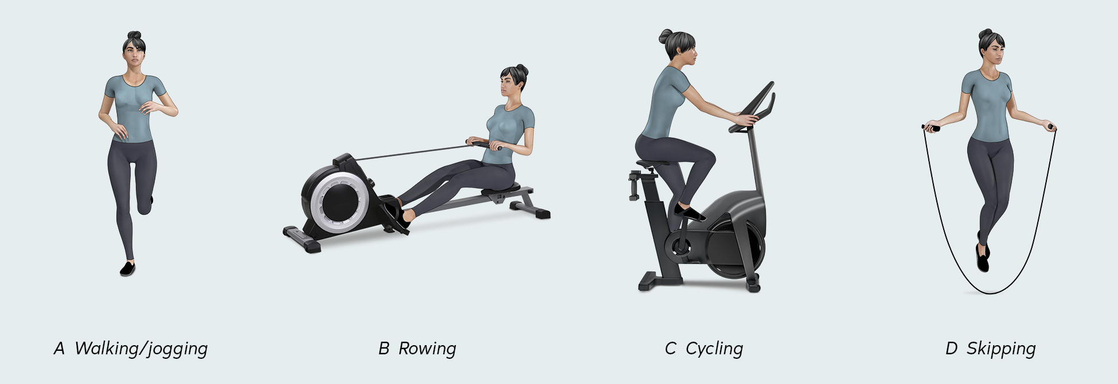

BALANCE EXERCISES
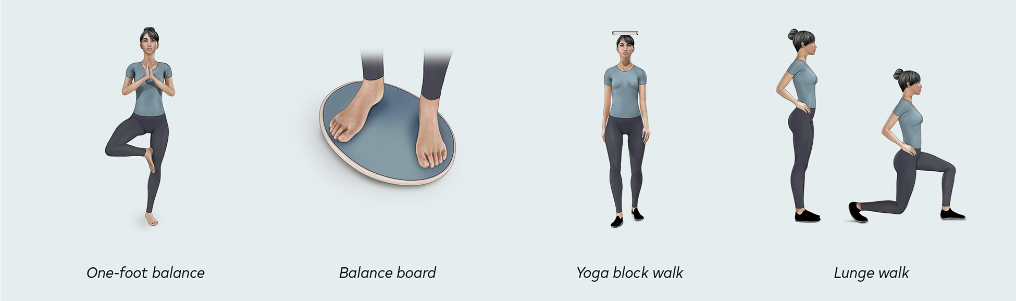

STABILITY EXERCISES
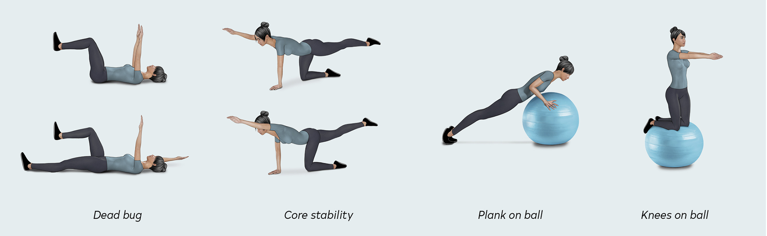

SQUAT EXERCISES
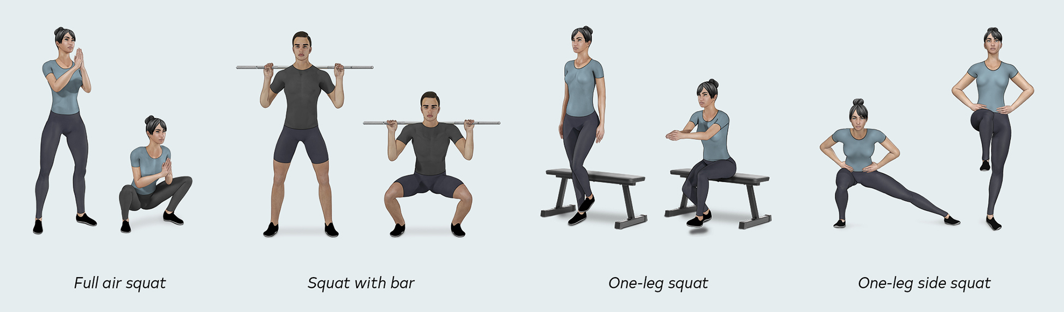

HINGE EXERCISES
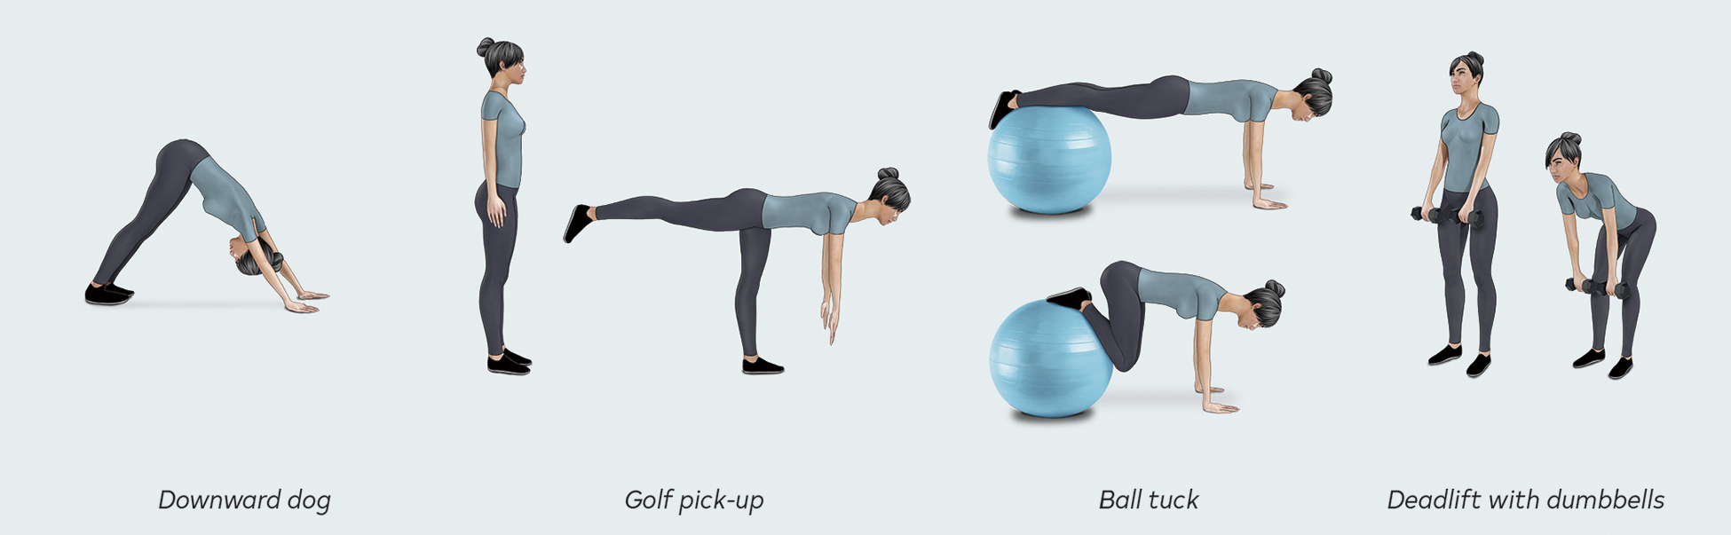

PUSHING EXERCISES
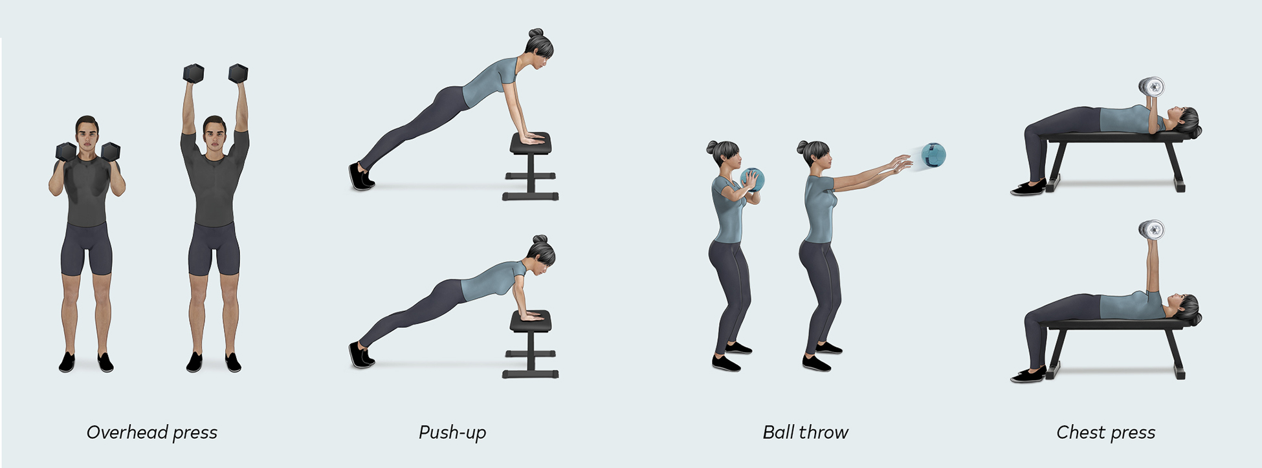

PULLING EXERCISES
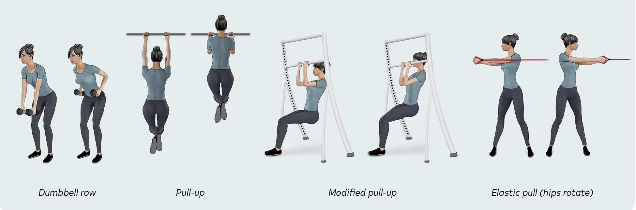

WHOLE-BODY STRETCHES
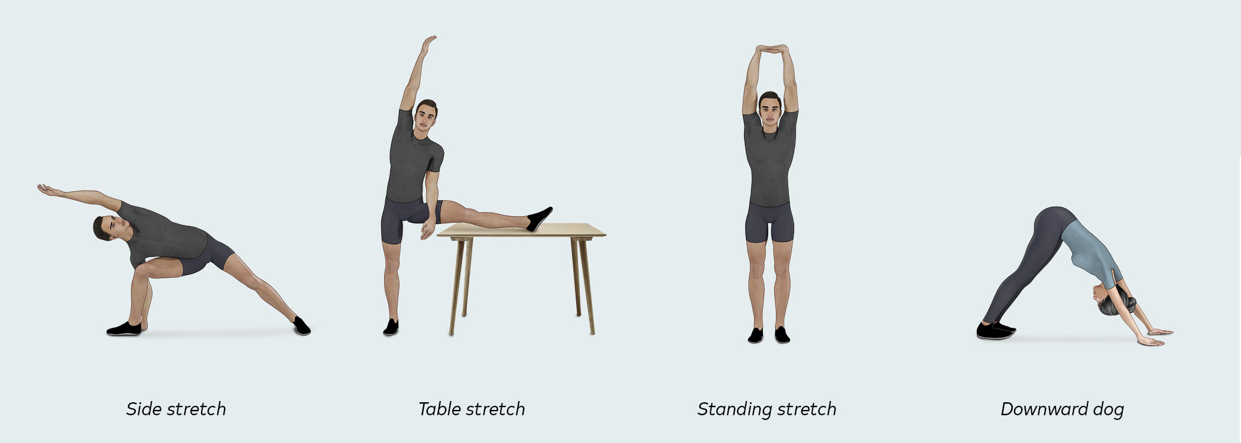

HIP STRETCHES
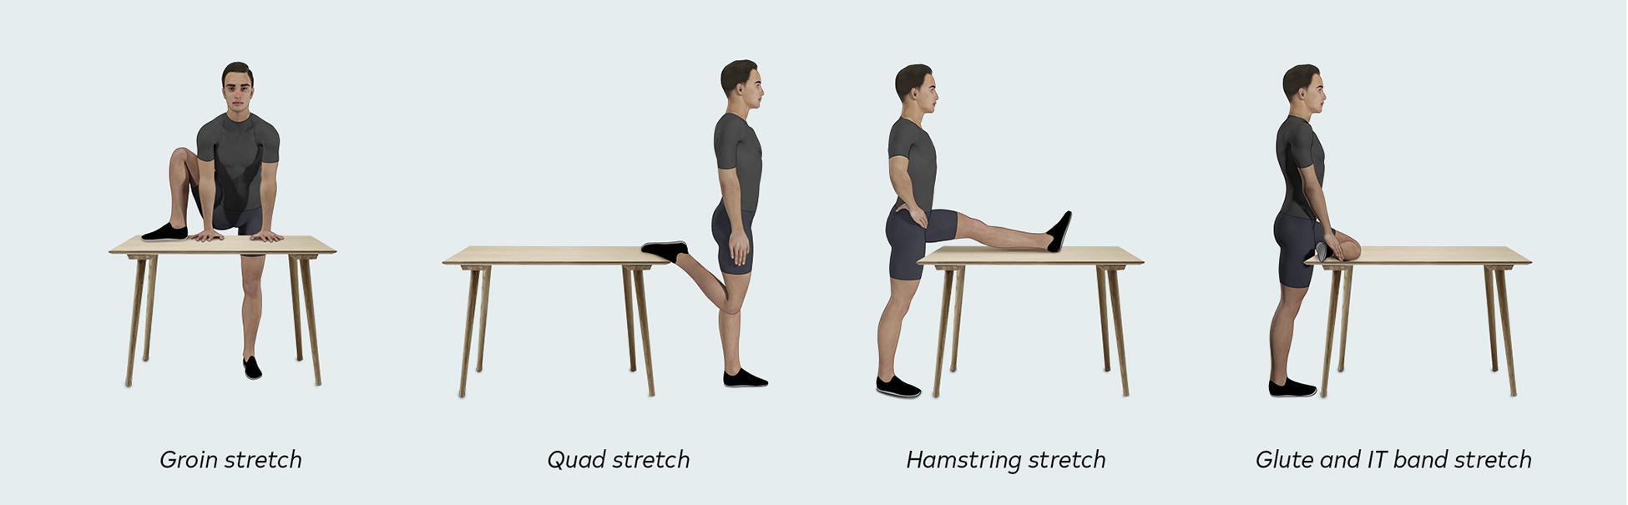

SHOULDER STRETCHES
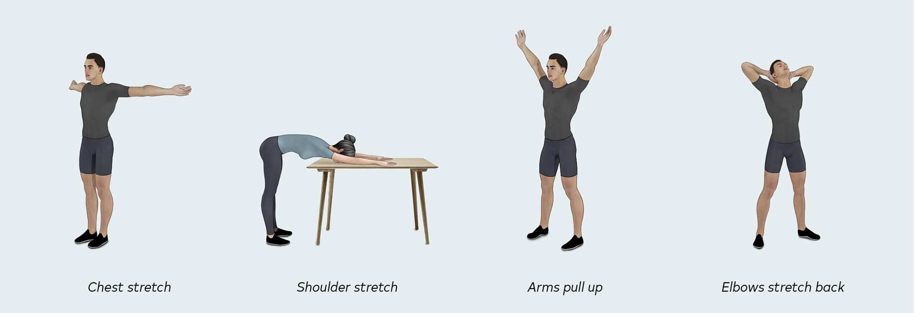
OTHER STRETCHES
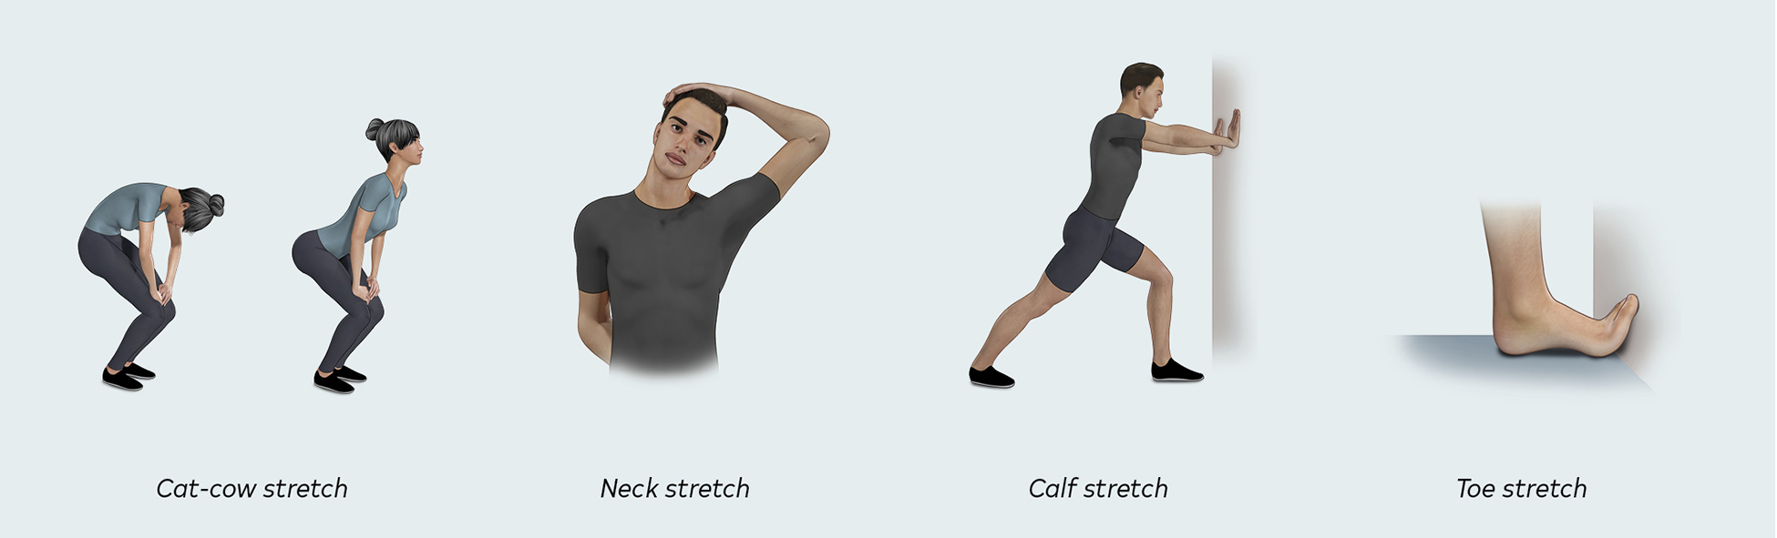
MYOFASCIAL RELEASE TECHNIQUES
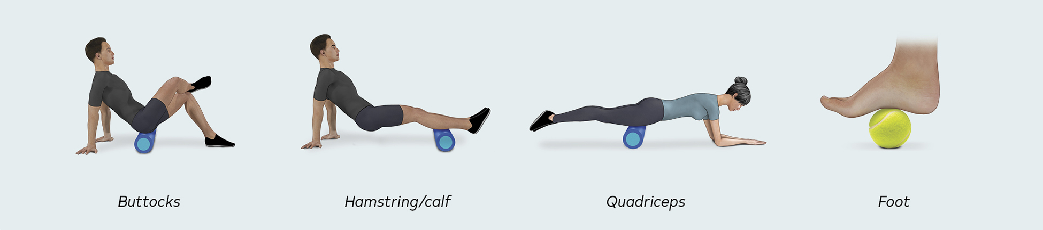
RELAXATION

